**EMT ASSIGNMENT**

    PARALLEL PLATE CAPACITOR

NAME        :-   HARSH KUMAR

SRN            :-   PES1UG19EE038

PESU ID     :-   PES1201900555

EMAIL ID  :-  harshkumar12304@gmail.com

CAPACITOR :- A Capacitor is a device used for storing electrical energy which can be used in a controlled manner.

CAPACITANCE :- The capacitance of a capacitor is the ability of a capacitor to store an electric charge per unit of [**voltage**](https://physicsabout.com/voltage/) across its plates of a capacitor. Capacitance is found by dividing electric charge with voltage by the formula C=Q/V. Its unit is Farad.

PARALLEL PLATE CAPACITOR

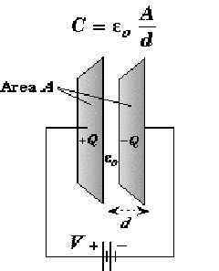

A parallel plate capacitor is an arrangement of two metal plates connected in parallel separated from each other by some distance. A dielectric medium occupies the gap between the plates. The dielectric medium can be air, vacuum or some other non-conducting material like mica, glass, paper wool, electrolytic gel and many others.

STEPS FOR FINDING CAPACITANCE OF A PARALLEL PLATE CAPACITOR

1. Given V, use E = - ∇V to find E
2. Use D = 𝟄E to find D
3. Evaluate D at either capacitor plate, D = Ds = Dn an
4. Recognize that 𝞺s = Dn
5. Find Q by a surface integration over the capacitor plate

Q = ∫𝐷 ∙ 𝑑𝑠 = ∫ 𝜀𝐸. 𝑑𝑠 = 𝜀𝐸 ∫ 𝑑𝑠

Let Area of the plate is S m2

Now Q = ∈ 𝐸 𝑆

We know that V = E.d where E is the electric field between the plates of a capacitor separated by a distance d.

Now, C = Q/V = ∈ES/ED

Hence, C = Q/V = ∈S/D

NUMERICALS ON PARALLEL PLATE CAPACITORS

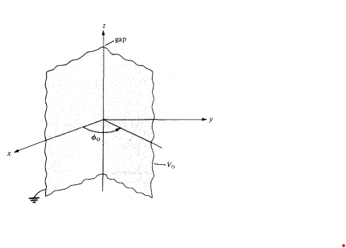

Problem 1 : Semi-Infinite conducting planes ɵ=0 and ɵ=π/6 are separated by an infinitesimal insulating gap as in Figure. If V(ɵ=0)=0 and V(ɵ=π /6)=100V, calculate V and E in the region between the planes.

Solution:

As V depends only on, Laplace's equation in cylindrical coordinates becomes

∇2V = (1/ ρ2)(d2V/dɵ) = 0

Since ρ=0 is excluded due to the insulating gap, we can multiply by ρ2 to obtain

d2V/dɵ = 0

which is integrated twice to give , V = Aɵ+ B

We apply the boundary conditions to determine constants A and B. When ɵ = 0, V = 0,

0 = 0 + B→B = 0

When ɵ = ɵ0 and V=V0 ,

V0 =Aɵ0 → A=V0/ɵ0

Hence, V = (V0/ɵ0) ɵ

and E = -∇V = -(1/ρ)(dV/dɵ)aɵ = -(V0/ ρɵ0)aɵ

Substituting V0 =100 and ɵ0 = π/6 gives

V = (600/π)ɵ and E = (600/πρ)aɵ

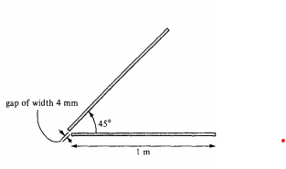Problem 2. Two conducting plates of size 1 X 5 m are inclined at 45° to each other with a gap of width 4 mm separating them as shown in Figure. Determine an approximate value of the charge per plate if the plates are maintained at a potential difference of 50 V. Assume that the medium between them has εr = 1.5.

Solution :-

Now we know that,

E = -∇V = -(1/ρ)(dV/dɵ)aɵ = -(V0/ρɵ0)aɵ

D = **ε**0E

ρ = Dn(ɵ=0) = -(V0 ε/ ρɵ0)

The charge on the plate ɵ = 0 is

Q = ∫ ρsds = -(V0ε/ɵ) ∫z=0 to L   ∫ ρ=a to h [ l/ρ dzdρ ] = -(V0 ε / ɵ0)L ln(b/a)

C = Q/V = (εL/ ɵ0) ln(b/a)

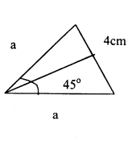

aSin45*/2 = 2

a = 2/Sin22.5*

a = 5.226 mm

C = [1.5*10-9*5*ln(1000/5.226)]/[36π * π/4]

C = 444 pF

Q = CV0 = 444*10-12 * 50 = 22.2nC